Activity 2.2.2 Mechanical Gears

Introduction
What do a guitar, a bicycle, an eggbeater, and a sewing machine have in common? They all use gears to increase, decrease, or redirect power. Gears come in all sizes. A mechanical wind-up watch has very small gears, while the gears used to lift a bridge to allow ships to pass underneath are huge. Different gear configurations are used for different purposes.

In this activity you and your classmates will build gear assemblies and observe how they are used. This information will come in handy when your class designs and builds an automated factory assembly line.

Equipment
Gateway notebook
Pencil
Ruler
VEX parts
Digital camera

Procedure
Complete the following assemblies using the VEX kit provided. You may vary from the original design as long as the finished product still performs the desired outcome. Have your teacher verify your mechanism after you complete each assembly, and then answer the questions beside the diagram on your document before going on to the next mechanism. All questions should be answered in complete sentences and in different color. Take a picture of each of your completed assemblies and place them in your document.

It is not necessary for all models to look exactly like the photographed model, as long as the mechanism works correctly.

Simple Gear Train (A and B)  - What is the relationship of the input shaft compared to the output shaft?  - Label the drive and driven gears.  In gear train A, is the speed increased, decreased, or constant?  In gear train B, is the speed increased, decreased, or constant?  In gear train A, is the torque increased, decreased, or constant?  In gear train B, is the torque increased, decreased, or constant?  What is the gear ratio of gear train A?  What is the gear ratio of gear train B? | - 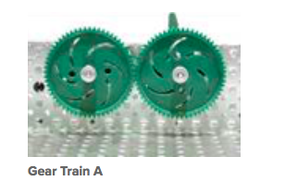  B. 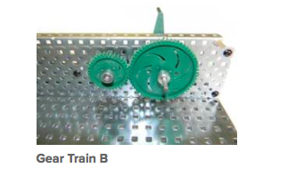
Is the flow of power reversible? (Can you make the input shaft turn by turning the output shaft?)
Do the gears move in the same or in the opposite direction?
List an example where this mechanism might be used. Go online to find a real example
Simple Gear Train with Idler  - What is the relationship of the input shaft compared to the output shaft?  - Label the drive, driven, and idler gear.  Is the speed increased, decreased, or constant?  Is the torque increased, decreased, or constant? | 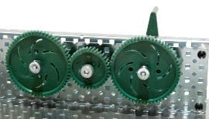
What is the gear ratio?
Is the flow of power reversible? (Can you make the input shaft turn by turning the output shaft?)
What is the direction of travel between the input and output gears?
Predict what the direction of travel would be between the input and output gears if the idler gear was eliminated from the mechanism.
List an example where this mechanism might be used. Go online to find a real example

Bevel Gear Assembly (use different sizes)  - What is the angle of the input shaft compared to the output shaft?  Is the speed increased, decreased, or constant?  Is the torque increased, decreased, or constant?  If the input gear was larger than the output gear, how would that affect the speed and torque? | 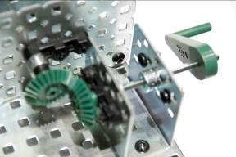
What is the gear ratio?
Is the flow of power reversible? (Can you make the input shaft turn by turning the output shaft?)
List an example where this mechanism might be used. . Go online to find a real example

Differential Gear (Optional)
- What types of gears are used to make the differential?
- Do the axles turn in the opposite or in the same direction?
- List an example where this mechanism might be used. Go online to find a real example.
- What is the purpose of a differential?

Worm and Wheel  - What is the angle of the input shaft compared to the output shaft?  Is the speed increased, decreased, or constant?  Is the torque increased, decreased, or constant?  Label the worm and wheel gears.  What is the gear ratio?  Is the flow of power reversible? (Can you make the input shaft turn by turning the output shaft?) | 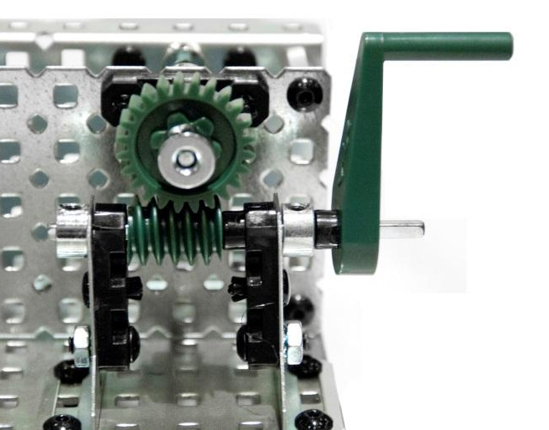
Is the direction of travel reversible? (Does the mechanism still work if the input shaft is turned in the opposite direction?)
List an example where this mechanism might be used. Go online to find a real example

Leadscrew  - What is the type of input movement?  (rotary, reciprocating, or linear)  What is the type of output movement?  (rotary, reciprocating, or linear)  How many revolutions of the crank are needed to move the screw block 1 inch?  Is the flow of power reversible? (Can you make the lead screw turn by pushing the screw block?)  Which is increased in the output? Force or speed?  Is the direction of travel reversible? (Does the mechanism still work if the crank is turned in the opposite direction?)  List an example where this mechanism might be used. Go online to find a real example lead screw. | 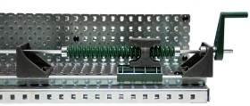  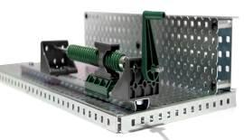
Rack and Pinion  - What is the type of input movement? (rotary or linear)  What is the type of output movement?  Label the rack gear and pinion gear.  If the diameter of the pinion gear were increased, would the rack move a shorter or longer distance with one revolution of the axle?  Is the flow of power reversible? (Can you make the input shaft turn by sliding the output shaft?)  Is the direction of travel reversible? (Does the mechanism still work if the input shaft is turned in the opposite direction?)  List an example where this mechanism might be used. | 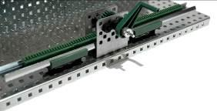  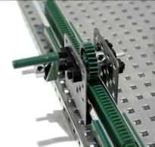
Universal Joint  - What is the angular range between the input shaft and the output shaft in which this mechanism will work?  Is the speed increased, decreased, or constant?  Is the torque increased, decreased, or constant?  What is the speed ratio of the input shaft to the output shaft?  Is the flow of power reversible? (Can you make the input shaft turn by turning the output shaft?)  Do the input and output shafts turn in the same direction?  List an example where this mechanism might be used. Go online to find a real example. | 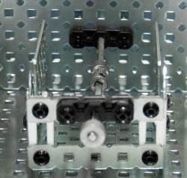  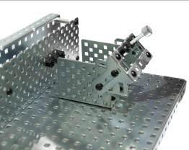

Chain Drive and Tank drive  - Label the drive and driven gears.  What is the angle of the input shaft compared to the output shaft?  In gear train A, is the speed increased, decreased, or constant?  In gear train A, is the torque increased, decreased, or constant?  In gear train A, what is the input to output ratio?  What happens to speed, torque, and gear ratio if the smaller gear becomes the drive gear (shown in picture B)?  Does the input shaft turn in the same or opposite direction of the output shaft? | A.  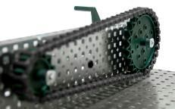  B.  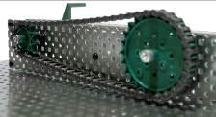
List an example of where this mechanism might be used. Go online to find a real example
What is the advantage of using a chain drive over spur gears?
Belt Drive  - Label the drive and driven pulleys.  What is the angle of the input shaft compared to the output shaft?  Is the speed increased, decreased, or constant?  Is the torque increased, decreased, or constant?  What is the input to output ratio? (Measure the number of rotations on the driven and driving axles.)  What happens to speed and torque if the drive pulley is larger?  Does the input shaft turn in the same or in the opposite direction of the output shaft?  What happens if the belt is crossed?  List an example of where this mechanism might be used.  Why would you use a belt drive instead of a chain drive? | 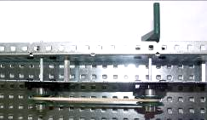  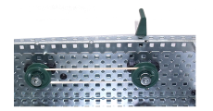  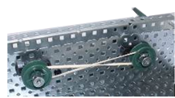
Note: Use double-sided tape to create friction between pulley wheels and shaft collars as shown. | 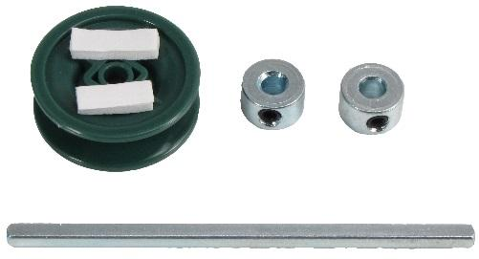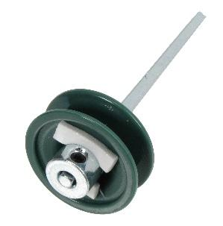

Crank and Slider  - Label the crank and slider.  - The input to this system is what type of motion (rotary, reciprocating, or linear)?  The output of this system is what type of motion (rotary, reciprocating, or linear)?  How far does the slider move with each revolution of the crank?  If the diameter of the crank gear were increased, would the slider move a shorter or longer distance?  Is the flow of power reversible? (Can you make the crank gear turn by pushing the slider?)  List an example of where this mechanism might be used. Go online to find a real example | 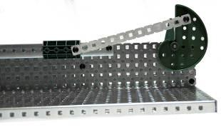  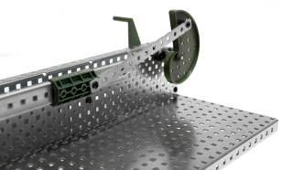
Cam and Follower  - Label the Cam and Follower  - What is the type of input movement? (rotary, reciprocating, or linear)  What is the type of output movement?  How many times does the follower move up and down with one revolution of the crank?  Is the flow of power reversible? (Can you make the crank turn by pushing the follower?)  Is the direction of travel reversible? (Does the mechanism still work if the crank is turned in the opposite direction?)  List an example where this mechanism might be used. Go online to find a real example | 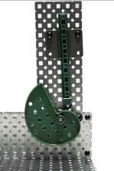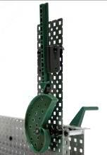

Conclusion
- Which mechanisms can increase speed?
Which mechanisms can increase torque?
Which mechanisms allow the reversal of power?

